Chapter – 5 Interrupt Operations

* Interrupt is signals send by an external device to the processor, to request the processor to perform a particular task or work.
* Mainly in the microprocessor based system the interrupts are used for data transfer between the peripheral and the microprocessor.
* The processor will check the interrupts always at the 2nd T-state of last machine cycle.
* If there is any interrupt it accept the interrupt and send the INTA (active low) signal to the peripheral.
* The vectored address of particular interrupt is stored in program counter.
* The processor executes an interrupt service routine (ISR) addressed in program counter.
* It returned to main program by RET instruction.

**Need for Interrupt:** Interrupts are particularly useful when interfacing I/O devices that provide or require data at relatively low data transfer rate.

## Interrupt Operations

The transfer of data between the microprocessor and input /output devices takes place using various modes of operations like programmed I/O, interrupt I/O and direct memory access. In programmed I/O, the processor has to wait for a long time until I/O module is ready for operation. So the performance of entire system degraded. To remove this problem CPU can issue an I/O command to the I/O module and then go to do some useful works. The I/O device will then interrupt the CPU to request service when it is ready to exchange data with CPU. In response to an interrupt, the microprocessor stops executing its current program and calls a procedure which services the interrupt.

The interrupt is a process of data transfer whereby an external device or a peripheral can inform the processor that it is ready for communication and it requests attention. The response to an interrupt request is directed or controlled by the microprocessor.

## Process of interrupt Operation From the point of view of I/O unit

* I/O device receives command from CPU
* The I/O device then processes the operation
* The I/O device signals an interrupt to the CPU over a control line.
* The I/O device waits until the request from CPU.

## From the point of view of processor

* The CPU issues command and then goes off to do its work.
* When the interrupt from I/O device occurs, the processor saves its program counter & registers of the current program and processes the interrupt.
* After completion for interrupt, processor requires its initial task.

## Polling versus Interrupt

* Each time the device is given a command, for example *``move the read head to sector 42 of the floppy disk''* the device driver has a choice as to how it finds out that the command has completed. The device drivers can either poll the device or they can use interrupts.
* Polling the device usually means reading its status register every so often until the device's status changes to indicate that it has completed the request.
* Polling means the CPU keeps checking a flag to indicate if something happens.
* An interrupt driven device driver is one where the hardware device being controlled will cause a hardware interrupt to occur whenever it needs to be serviced.
* With interrupt, CPU is free to do other things, and when something happens, an interrupt is generated to notify the CPU. So it means the CPU does not need to check the flag.
* Polling is like picking up your phone every few seconds to see if you have a call. Interrupts are like waiting for the phone to ring.
* Interrupts win if processor has other work to do and event response time is not critical.
* Polling can be better if processor has to respond to an event ASAP; may be used in device controller that contains dedicated secondary processor.

## Advantages of interrupt over Polling

* Interrupts are used when you need the fastest response to an event. For example, you need to generate a series of pulses using a timer. The timer generates an interrupt when it overflows and within 1 or 2 sec, the interrupt service routine is called to generate the pulse. If polling were used, the delay would depend on how often the polling is done and could delay response to several msecs. This is thousands times slower.
* Interrupts are used to save power consumption. In many battery powered applications, the microcontroller is put to sleep by stopping all the clocks and reducing power consumption to a few micro amps. Interrupts will awaken the controller from sleep to consume power only when needed. Applications of this are hand held devices such as TV/VCR remote controllers.
* Interrupts can be a far more efficient way to code. Interrupts are used for program debugging.

## Interrupt structures:

A processor is usually provided with one or more interrupt pins on the chip. Therefore a special mechanism is necessary to handle interrupts from several devices that share one of these interrupt lines. There are mainly two ways of servicing multiple interrupts which are polled interrupts and daisy chain (vectored) interrupts.

## polled interrupts

Polled interrupts are handled by using software which is slower than hardware interrupts. Here the processor has the general (common) interrupt service routine (ISR) for all devices. The priority of the devices is determined by the order in which the routine polls each device. The processor checks the starting with the highest priority device. Once it determines the source of the interrupt, it branches to the service routine for that device.

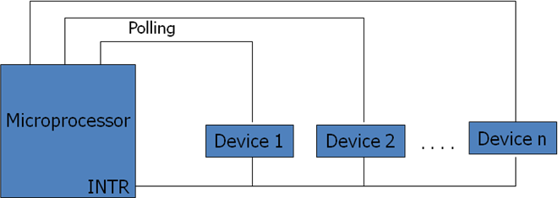

Fig: Polled Interrupt

Here several eternal devices are connected to a single interrupt line (INTR) of the microprocessor. When INTR signal goes up, the processor saves the contents of PC and other registers and then branches to an address defined by the manufactures of the processor. The user can write a program at this address to find the source of the interrupt by starting the polled from highest priority device.

## Daisy chain (vectored) interrupt

In polled interrupt, the time required to poll each device may exceed the time to service the device through software. To improve this, the faster mechanism called vectored or daisy chain interrupt is used. Here the devices are connected in chain fashion. When INTR pin goes up, the

processor saves its current status and then generates INTA signal to the highest priority device. If this device has generated the interrupt, it will accept the INTA; otherwise it will push

INTAto the next priority device until the INTAis accepted by the interrupting device.

When INTAis accepted, the device provides a means to the processor for findings the interrupt address vector using external hardware. The accepted device responds by placing a word on the data lines which becomes the vector address with the help of any hardware through which the processor points to appropriate device service routine. Here no general interrupt service routine need first that means appropriate ISR of the device will be called.

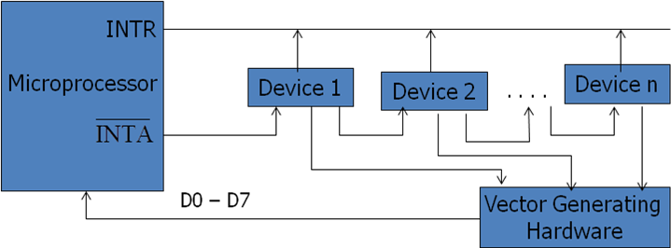

Fig: Vectored (Daisy Chain) Interrupt

## Interrupt Processing Sequence

The occurrence of interrupt triggers a number of events, both in processor hardware and in software. The interrupt driven I/O operation takes the following steps.

* The I/O unit issues an interrupt signal to the processor for exchange of data between them.
* The processor finishes execution of the current instruction before responding to the interrupt.
* The processor sends an acknowledgement signal to the device that it issued the interrupt.
* The processor transfers its control to the requested routine called “Interrupt Service Routine (ISR)” by saving the contents of program status word (PSW) and program counter (PC).
* The processor now loads the PC with the location of interrupt service routine and the fetches the instructions. The result is transferred to the interrupt handler program.
* When interrupt processing is completed, the saved register’s value are retrieved from the stack and restored to the register.
* Finally it restores the PSW and PC values from the stack.

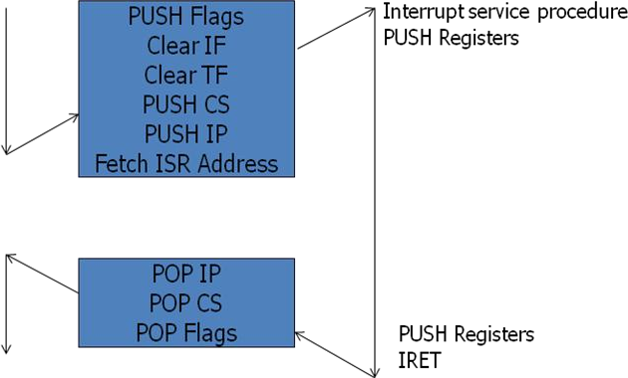

Fig: Interrupt Response for 8086 Microprocessor

The figure summarizes these steps. The processor pushes the flag register on the stack, disables the INTR input and does essentially an indirect call to the interrupt service procedure. An IRET function at the end of interrupt service procedure returns execution to the main program.

## Interrupt priority:

Microcomputers can transfer data to or from an external devices using interrupt through INTR pin. When device wants to communicate with the microcomputer, it connects to INTR pin and makes it high or low depending on microcomputer. The microcomputer responds by sending signal via its pin called interrupt acknowledgement INTA. In differentiation with the occurrence of interrupts, basically following interrupts exist.

## External interrupts:

These interrupts are initiated by external devices such as A/D converters and classified on following types.

* + Maskable interrupt :

It can be enabled or disabled by executing instructions such as EI and DI. In 8085, EI sets the interrupt enable flip flop and enables the interrupt process. DI resets the interrupt enable flip flop and disables the interrupt.

* + Non-maskable interrupt:

It has higher priority over maskable interrupt and cannot be enabled or disabled by the instructions.

## Internal interrupts:

* + These are indicated internally by exceptional conditions such as overflow, divide by zero, and execution of illegal op-code. The user usually writes a service routine to take correction measures and to provide an indication in order to inform the user that exceptional condition has occurred.
  + There can also be activated by execution of TRAP instruction. This interrupt means TRAP is useful for operating the microprocessor in single step mode and hence important in debugging.
  + These interrupts are used by using software to call the function of an operating system. Software interrupts are shorter than subroutine calls and they do not need the calling program to know the operating system’s address in memory.

If the processor gets multiple interrupts, then we need to deal these interrupts one at a time and the dealing approaches are:

## Sequential processing of interrupts

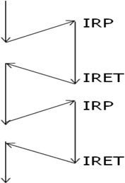When user program is executing and an interrupt occurs interrupts are disabled immediately. After the interrupt service routine completes, interrupts are enabled before resuming the user program and the processor checks to see if additional interrupts have occurred.

Fig: Sequential Interrupt Service

## Priority wise processing of interrupts:

The drawback of sequential processing is that it does not take account of relative priority or time critical needs. The alternative form of this is to define priorities for interrupts and to allow an interrupt of higher priority to cause a lower priority interrupts pause until high priority interrupt completes its function.

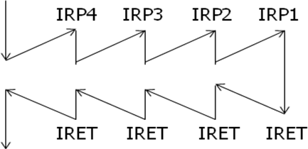

Fig: Priority wise Interrupt service

## Interrupt Service Routine

* An interrupt service routine (ISR) is a software routine that hardware invokes in response to an interrupt.
* ISRs examine an interrupt and determine how to handle it.
* ISRs handle the interrupt, and then return a logical interrupt value.
* Its central purpose is to process the interrupt and then return control to the main program.
* An ISR must perform very fast to avoid slowing down the operation of the device and the operation of all lower priority ISRs.
* As in procedures, the last instruction in an ISR should be iret.

ISR is responsible for doing the following things:

* 1. Saving the processor context

Because the ISR and main program use the same processor registers, it is the responsibility of the ISR to save the processor’s registers before beginning any processing of the interrupt. The processor context consists of the instruction pointer, registers, and any flags. Some processors perform this step automatically.

* 1. Acknowledging the interrupt

The ISR must clear the existing interrupt, which is done either in the peripheral that generated the interrupt, in the interrupt controller, or both.

* 1. Restoring the processor context

After interrupt processing, in order to resume the main program, the values that were saved prior to the ISR execution must be restored. Some processors perform this step automatically.

## Interrupt Processing in 8085

* Interrupt is signals send by an external device to the processor, to request the processor to perform a particular task or work.
* Mainly in the microprocessor based system the interrupts are used for data transfer between the peripheral and the microprocessor.
* The processor will check the interrupts always at the 2nd T-state of last machine cycle.
* If there is any interrupt it accept the interrupt and send the INTA (active low) signal to the peripheral.
* The vectored address of particular interrupt is stored in program counter.
* The processor executes an interrupt service routine (ISR) addressed in program counter.
* It returned to main program by RET instruction.

## Types of Interrupts:

It supports two types of interrupts.

1. Hardware
2. Software

## Software interrupts:

The software interrupts are program instructions. These instructions are inserted at desired locations in a program.

The 8085 has eight software interrupts from RST 0 to RST 7. The vector address for these interrupts can be calculated as follows.

Interrupt number * 8 = vector address For RST 5; 5 * 8 = 40 = 28H

Vector address for interrupt RST 5 is 0028H

The Table shows the vector addresses of all interrupts.

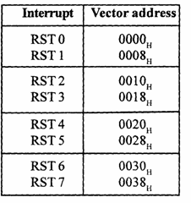

## Interrupt Pins and Priorities (Hardware interrupts)

An external device initiates the hardware interrupts and placing an appropriate signal at the interrupt pin of the processor.

If the interrupt is accepted then the processor executes an interrupt service routine.

The 8085 has five hardware interrupts

(1) TRAP (2) RST 7.5 (3) RST 6.5 (4) RST 5.5 (5) INTR

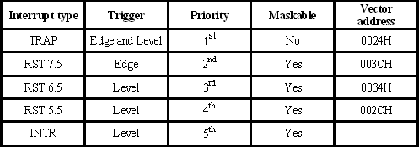

# TRAP:

* + - * This interrupt is a non-maskable interrupt. It is unaffected by any mask or interrupt enable.
      * TRAP bas the highest priority and vectored interrupt.
      * TRAP interrupt is edge and level triggered. This means hat the TRAP must go high and remain high until it is acknowledged.
      * In sudden power failure, it executes a ISR and send the data from main memory to backup memory.
      * The signal, which overrides the TRAP, is HOLD signal. (i.e., If the processor receives HOLD and TRAP at the same time then HOLD is recognized first and then TRAP is recognized).
      * There are two ways to clear TRAP interrupt.
        1. By resetting microprocessor (External signal)
        2. By giving a high TRAP ACKNOWLEDGE (Internal signal)

# RST 7.5:

* + - * The RST 7.5 interrupt is a maskable interrupt.
      * It has the second highest priority.
      * It is edge sensitive. ie. Input goes to high and no need to maintain high state until it recognized.
      * Maskable interrupt. It is disabled by,
        1. DI instruction
        2. System or processor reset.
        3. After reorganization of interrupt.
      * Enabled by EI instruction.

## RST 6.5 and 5.5:

* + - * The RST 6.5 and RST 5.5 both are level triggered. . ie. Input goes to high and stay high until it recognized.
      * Maskable interrupt. It is disabled by,
        1. DI, SIM instruction
        2. System or processor reset.
        3. After reorganization of interrupt.
      * Enabled by EI instruction.
      * The RST 6.5 has the third priority whereas RST 5.5 has the fourth priority.

# INTR:

* + - * INTR is a maskable interrupt.
      * It is disabled by,
        1. DI, SIM instruction
        2. System or processor reset.
        3. After reorganization of interrupt.
      * Enabled by EI instruction.
      * Non- vectored interrupt. After receiving INTA (active low) signal, it has to supply the address of ISR.
      * It has lowest priority.
      * It is a level sensitive interrupts. ie. Input goes to high and it is necessary to maintain high state until it recognized.
      * The following sequence of events occurs when INTR signal goes high.
        1. The 8085 checks the status of INTR signal during execution of each instruction.
        2. If INTR signal is high, then 8085 complete its current instruction and sends active low interrupt acknowledge signal, if the interrupt is enabled.
        3. In response to the acknowledge signal, external logic places an instruction OPCODE on the data bus. In the case of multibyte instruction, additional interrupt acknowledge machine cycles are generated by the 8085 to transfer the additional bytes into the microprocessor.
        4. On receiving the instruction, the 8085 save the address of next instruction on stack and execute received instruction.

## Using Programmable Interrupt Controller (PIC) Priority interrupt controller (PIC)

The INTR pin can be used for multiple peripherals and to determine priorities among these devices when two or more peripherals request interrupt service simultaneously, PIC is used. If there are simultaneous requests, the priorities are determined by the encoder, it responds to the higher level input, ignoring the lower level input. The drawback of the scheme is that the interrupting device connected to input I7 always has the highest priority. The PIC includes a status register and a priority comparator in addition to a priority encoder.

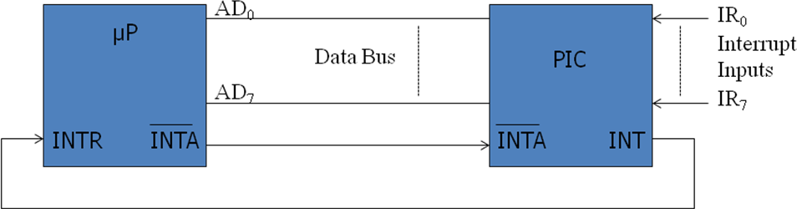

Fig: Multiple Interrupts using PIC

Today this device is replaced by a more versatile one called a programmable interrupt controller 8259A. When an 8259A receives an interrupt signal on one of its IR inputs, it

sends an interrupt request signal to the INTR input of the µP. Then INTA pulses will cause the PIC to release vectoring information onto the data bus.

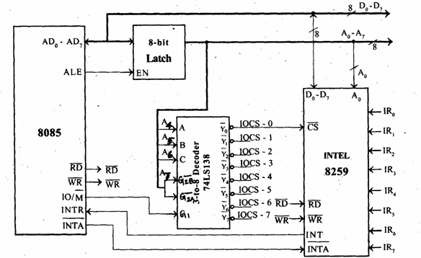

* + - * It requires two internal address and they are A =0 or A = 1.
      * It can be either memory mapped or I/O mapped in the system. The interfacing of 8259 to 8085 is shown in figure is I/O mapped in the system.
      * The low order data bus lines D0-D7 are connected to D0-D7 of 8259.
      * The address line A0 of the 8085 processor is connected to A0 of 8259 to provide the internal address.
      * The 8259 require one chip select signal. Using 3-to-8 decoder generates the chip select signal for 8259.
      * The address lines A4, A5 and A6 are used as input to decoder.
      * The control signal IO/M (low) is used as logic high enables for decoder and the address line A7 is used as logic low enable for decoder.
      * The I/O addresses of 8259 are shown in table below.

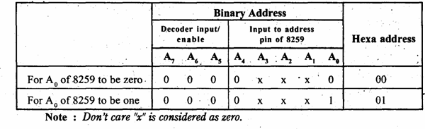

## Working of 8259 with 8085 processor:

* + - * First the 8259 should be programmed by sending Initialization Command Word (ICW) and Operational Command Word (OCW). These command words will inform 8259 about the following,
        1. Type of interrupt signal (Level triggered / Edge triggered).
        2. Type of processor (8085/8086).
        3. Call address and its interval (4 or 8)
        4. Masking of interrupts.
        5. Priority of interrupts.
        6. Type of end of interrupts.
      * Once 8259 is programmed it is ready for accepting interrupt signal. When it receives an interrupt through any one of the interrupt lines IR0-IR7 it checks for its priority and also checks whether it is masked or not.
      * If the previous interrupt is completed and if the current request has highest priority and unmasked, then it is serviced.
      * For servicing this interrupt the 8259 will send INT signal to INTR pin of 8085.
      * In response it expects an acknowledge INTA (low) from the processor.
      * When the processor accepts the interrupt, it sends three INTA (low) one by one.
      * In response to first, second and third INTA (low) signals, the 8259 will supply CALL opcode, low byte of call address and high byte of call address respectively. Once the processor receives the call opcode and its address, it saves the content of program counter (PC) in stack and load the CALL address in PC and start executing the interrupt service routine stored in this call address.

## How INTR pin is used in 8085:

The microprocessor checks INTR, one clock period before the last T- state of an instruction cycle. In the 8085, the call instructions require 18 T-states; therefore the INTR pulse should be high at least for 17.5 T-states. The INTR can remain high until the interrupt flip flop is set by the EI instruction in the service routine. If it remains high after the execution of the EI instruction, the processor will be interrupted again, as if it was a new interrupt.

## Interrupt instructions SIM instruction:

* + - * The 8085 provide additional masking facility for RST 7.5, RST 6.5 and RST 5.5 using SIM instruction.
      * This is a multipurpose instruction and used to implement the 8085 interrupts 7.5, 6.5, 5.5, and serial data output.
      * The masking or unmasking of RST 7.5, RST 6.5 and RST 5.5 interrupts can be performed by moving an 8-bit data to accumulator and then executing SIM instruction.
      * The format of the 8-bit data is shown below.

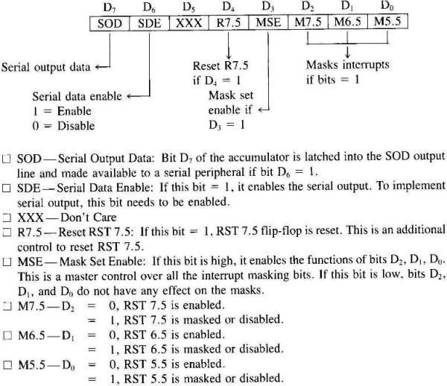

## RIM instruction

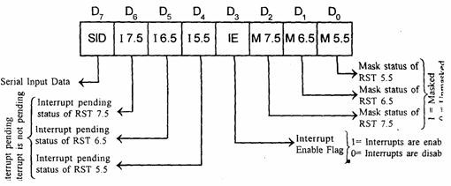

* + - * The status of pending interrupts can be read from accumulator after executing RIM instruction.
      * This is a multipurpose instruction used to read the status of RST 7.5, 6.5, 5.5 and read serial data input bit.
      * When RIM instruction is executed an 8-bit data is loaded in accumulator, which can be interpreted as shown in above fig.
      * Bits 0-2 show the current setting of the mask for each of RST 7.5, RST 6.5 and RST 5.5. They return the contents of the three masks flip flops. They can be used by a program to read the mask settings in order to modify only the right mask.
      * Bit 3 shows whether the maskable interrupt process is enabled or not. It returns the contents of the Interrupt Enable Flip Flop. It can be used by a program to determine whether or not interrupts are enabled.
      * Bits 4-6 show whether or not there are pending interrupts on RST 7.5, RST 6.5, and RST

5.5. Bits 4 and 5 return the current value of the RST5.5 and RST6.5 pins. Bit 6 returns the current value of the RST7.5 memory flip flop.

* + - * Bit 7 is used for Serial Data Input. The RIM instruction reads the value of the SID pin on the microprocessor and returns it in this bit.

# DI

* + - * Disable interrupts
      * The interrupt enable flip-flop is reset and all the interrupts except the TRAP are disabled. No flags are affected.
      * 1 byte instruction
      * Example: DI

# EI

* + - * Enable interrupts
      * The interrupt enable flip-flop is set and all interrupts are enabled.
      * No flags are affected.
      * After a system reset or the acknowledgement of an interrupt, the interrupt enable flip flop is reset, thus disabling the interrupts.
      * This instruction is necessary to enable the interrupts (except TRAP).
      * 1 byte instruction
      * Example: EI

## Interrupt Processing in 8086

The meaning of ‘interrupts’ is to break the sequence of operation. While the CPU is executing a program, on ‘interrupt’ breaks the normal sequence of execution of instructions, diverts its execution to some other program called Interrupt Service Routine (ISR).After executing ISR , the control is transferred back again to the main program. Interrupt processing is an alternative to polling.

## Interrupt Pins INTR and NMI

* + - * **INTR** is a maskable hardware interrupt. The interrupt can be enabled/disabled using STI/CLI instructions or using more complicated method of updating the FLAGS register with the help of the POPF instruction.
      * When an interrupt occurs, the processor stores FLAGS register into stack, disables further interrupts, fetches from the bus one byte representing interrupt type, and jumps to interrupt processing routine address of which is stored in location 4 * <interrupt type>. Interrupt processing routine should return with the IRET instruction.
      * **NMI** is a non-maskable interrupt. Interrupt is processed in the same way as the INTR interrupt. Interrupt type of the NMI is 2, i.e. the address of the NMI processing routine is stored in location 0008h. This interrupt has higher priority than the maskable interrupt.
      * **–** Ex: NMI, INTR.

## Interrupt Vector Table and its Organization

* + - * An interrupt vector is a pointer to where the ISR is stored in memory.
      * All interrupts (vectored or otherwise) are mapped onto a memory area called the Interrupt Vector Table (IVT).
* The IVT is usually located in memory page 00 (0000H - 00FFH).
* The purpose of the IVT is to hold the vectors that redirect the microprocessor to the right place when an interrupt arrives.

Interrupt Vector Table (IVT) is a 1024 bytes sized table that contains addresses of interrupts. Each address is of 4 bytes long of the form offset:segment, which represents the address of a routine to be called when the CPU receives an interrupt. IVT can hold maximum of 256 addresses (0 to 255). The interrupt number is used as an index into the table to get the address of the interrupt service routine. IVT act as pointers, unlike function call IVT need number as an argument then as a result IVT point us to interrupt service routine (ISR). ISR executes its code, when ISR finished then returns back to original statement. Interrupt vector table is a global table situated at the address 0000:0000H. The interrupt vector table is a feature of the Intel 8086/8088 family of microprocessors.

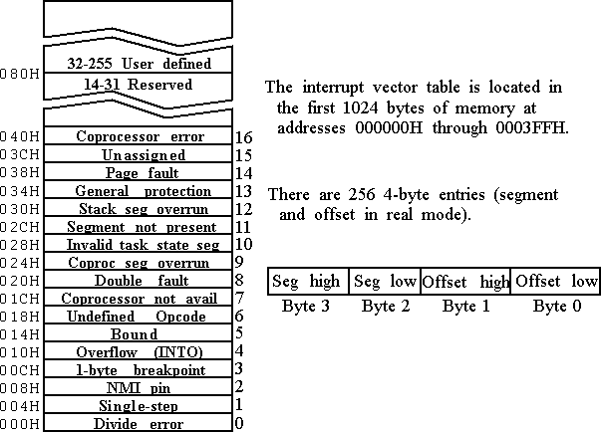

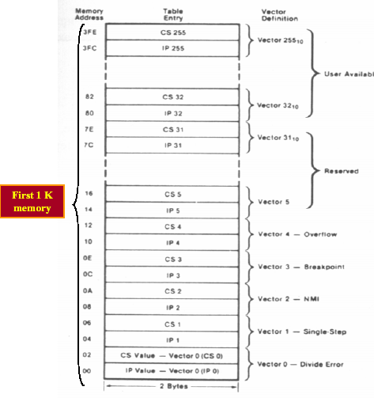

Fig: IVT Structure (Organization)

## Functions associated with INT00 to INT04

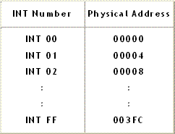

**INT 00 (divide error)**

* + - * INT00 is invoked by the microprocessor whenever there is an attempt to divide a number by zero.
      * ISR is responsible for displaying the message “Divide Error” on the screen

# INT 01

* + - * For single stepping the trap flag must be 1
      * After execution of each instruction, 8086 automatically jumps to 00004H to fetch 4 bytes for CS: IP of the ISR.
      * The job of ISR is to dump the registers on to the screen

## INT 02 (Non maskable Interrupt)

* + - * When ever NMI pin of the 8086 is activated by a high signal (5v), the CPU Jumps to physical memory location 00008 to fetch CS:IP of the ISR assocaiated with NMI.

## INT 03 (break point)

* + - * A break point is used to examine the cpu and memory after the execution of a group of Instructions.
      * It is one byte instruction whereas other instructions of the form “INT nn” are 2 byte instructions.

## INT 04 ( Signed number overflow)

* + - * There is an instruction associated with this INT 0 (interrupt on overflow).
      * If INT 0 is placed after a signed number arithmetic as IMUL or ADD the CPU will activate INT 04 if 0F = 1.
      * In case where 0F = 0 , the INT 0 is not executed but is bypassed and acts as a NOP.

## Software and Hardware Interrupt

**Types of Interrupts:** There are two types of Interrupts in 8086. They are:

1. **Hardware Interrupts** (External Interrupts). The Intel microprocessors support hardware interrupts through:
   * Two pins that allow interrupt requests, INTR and NMI
   * One pin that acknowledges, INTA, the interrupt requested on INTR.

## [Performance of Hardware Interrupts](http://www.8085projects.info/post/Performance-of-Hardware-Interrupts.aspx)

* NMI : Non maskable interrupts - TYPE 2 Interrupt
* INTR : Interrupt request - Between 20H and FFH

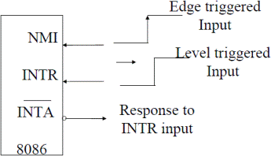

1. **Software Interrupts** (Internal Interrupts and Instructions) .Software interrupts can be caused by:
   * INT instruction - breakpoint interrupt. This is a type 3 interrupt.
   * INT <interrupt number> instruction - any one interrupt from available 256 interrupts.
   * INTO instruction - interrupt on overflow
   * Single-step interrupt - generated if the TF flag is set. This is a type 1 interrupt. When the CPU processes this interrupt it clears TF flag before calling the interrupt processing routine.
   * Processor exceptions: Divide Error (Type 0), Unused Opcode (type 6) and Escape opcode (type 7).
   * Software interrupt processing is the same as for the hardware interrupts.
   * - Ex: INT n (Software Instructions)
   * Control is provided through:
     + IF and TF flag bits
     + IRET and IRETD

## Performance of Software Interrupts[Performance of Software Interrupts](http://www.8085projects.info/post/Performance-of-Software-Interrupts.aspx)

* + It decrements SP by 2 and pushes the flag register on the stack.
  + Disables INTR by clearing the IF.
  + It resets the TF in the flag Register.
  + It decrements SP by 2 and pushes CS on the stack.
  + It decrements SP by 2 and pushes IP on the stack.
  + Fetch the ISR address from the interrupt vector table.

## Interrupt Priority Structure of 8086Interrupt Priorities

**8086 interrupts Summary**

An interrupt is a signal indicating that an event needing immediate attention has occurred there are two types of interrupts; external interrupt generated outside CPU by other hardware and internal interrupt generated within CPU as a result of an instruction or operation.

In 8086, two types of interrupts occurred.

## Hardware interrupt

These are external interrupts which uses NMI and INTR. When hardware interrupt is detected, the interrupt controller sends the interrupt code to the processor. When the code is finally acquired by the processor either from TNT opcode or from the interrupt controller. This is used by the processor to index the interrupt vector table to find the address of the interrupt handler. The 8086 specifies 256 different interrupts specified by type number or vector which is a pointer into IVT. The pointer is cs:ip values .

## Software interrupts

Software interrupts are used to publish internal services to outside world. These are internal interrupts like int and into and trap such as divide by zero or single step. Other software interrupts also included by 8086 processor. INT is used for breakpoint and INTO is used for overflow interrupt. Single step is the debugging mode interrupt for each instruction and divide error is dividing by zero interrupt.

## Interrupt vector table:

It is located in the first 1024 bytes of memory at address 000000-0003FFH. It contains 256 different 4-byte interrupt vectors. An interrupt vector contains the segment & offset address of the interrupt service provider.

## DOS & BIOS interrupts:

Dos interrupts services link applications with os services such as opening file, reading, writing content using certain functions of INT 4 H. BIOS interrupts control the screen disk controller and keyboard operation using INT 10H, 13H,16H etc.